**TASK 1:**

**Apply DFS search on the graph given below.**

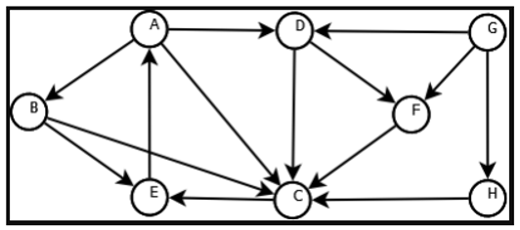

**CODE:**

__author__ *=* "Qaiser Abbas"

__copyright__ *=* "Copyright 2020, Artificial Intelligence lab-05"

__email__ *=* "qaiserabbas889@yahoo.com"

*def* *dfs*(graph,start,path*=*[]):

    stack*=*[start]

*while* stack:

        v*=*stack.pop(0)

*if* *not* v *in* path:

            path*=*path*+*[v]

            stack*=*graph[v]*+*stack

*return* path

graph*=*{ 'A':['B','C','D'],

        'B':['C','E'],

        'C':['E'],

        'D':['C','F'],

        'E':['A'],

        'F':['C'],

        'G':['D','F','H'],

        'H':['C']}

print('Depth First Search starting from A',dfs(graph,'A'))

print('\nDFS starting from B',dfs(graph,'B'))

print('\nDFS First Search starting from C',dfs(graph,'C'))

print('\nDFS First Search starting from D',dfs(graph,'D'))

print('\nDFS First Search starting from E',dfs(graph,'E'))

print('\nDFS First Search starting from F',dfs(graph,'F'))

print('\nDFS First Search starting from G',dfs(graph,'G'))

print('\nDFS First Search starting from H',dfs(graph,'H'))

**OUTPUT:**

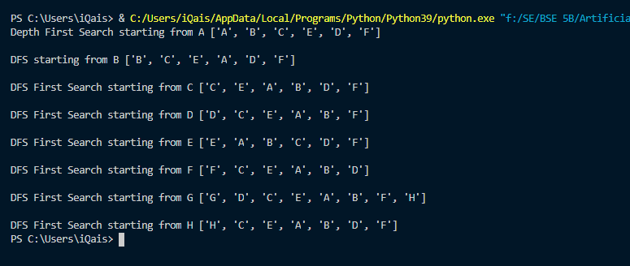

**TASK 2:**

**Implement DFS search algorithm while using recursion**

**CODE:**

__author__ *=* "Qaiser Abbas"

__copyright__ *=* "Copyright 2020, Artificial Intelligence lab-05"

__email__ *=* "qaiserabbas889@yahoo.com"

*def* *dfs*(graph,start,path*=*[]):

    path*=*path*+*[start]

*for* node *in* graph[start]:

*if* *not* node *in* path:

            path*=*dfs(graph,node,path)

*return* path

graph*=*{ 'Q':['S','T','U'],

        'R':['S','T','V'],

        'S':['Q','R','W'],

        'T':['Q','R','U'],

        'V':['R'],

        'W':['S'],

        'U':['Q','T']}

print('\n Depth First Search starting from Q is given below:\n',dfs(graph,'U'))

**OUTPUT:**

